Project Design Phase
Solution Architecture

Date | 25 June 2026
Team ID
Project Name | An employee requests installation of licensed software through the Service Catalog
Maximum Marks | 4 Marks

Solution Architecture:
The solution architecture bridges the gap between the business problem of manual software request handling and the technology solution implemented using ServiceNow. The architecture is designed to automate the complete software installation request lifecycle, including request submission, approvals, task creation, fulfilment, notifications, and request tracking.
Example - Solution Architecture Diagram:
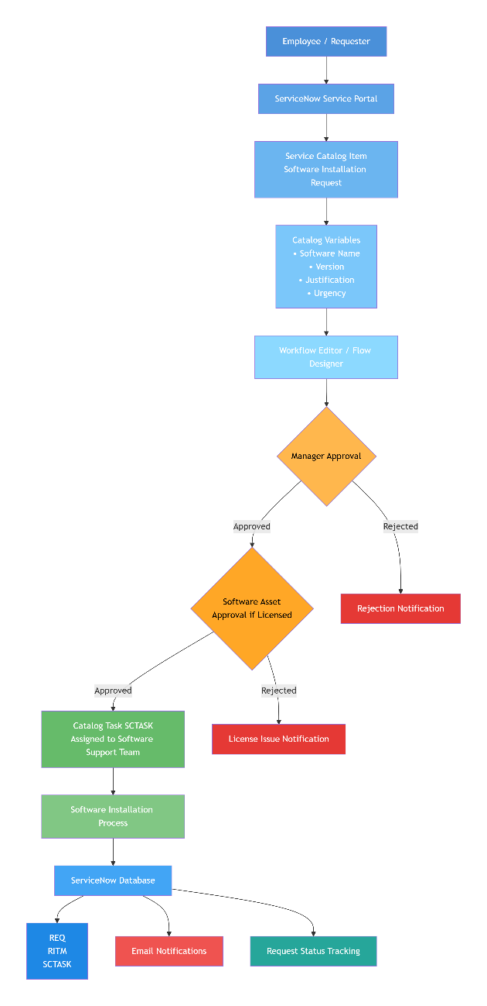
Figure 1: Architecture and data flow of the Software installation Request Automation

